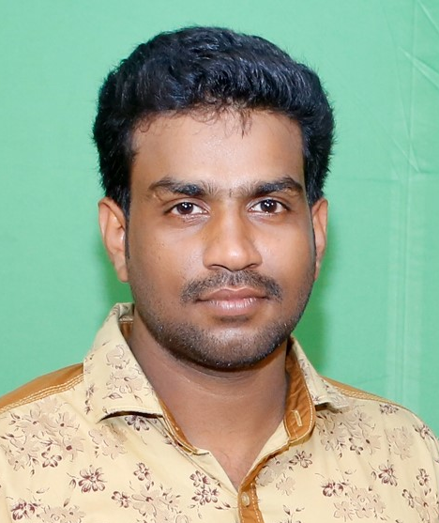
CURRICULUM VITAE

NITHEESH CHANDRAN
Nitheesh Bhavan
Thattarkonam P.O
Kollam – 691005
Kerala, India
Mob: +91 9645127586,
Emergency Contacts: +919446628163
Email: nitheeshapjak@gmail.com Blood Group: A+

CAREER OBJECTIVE

To work in a firm with a professional work driven environment where I can utilize and apply my knowledge skills which would enable me as a fresh graduate to grow while fulfilling organizational goals.

ACADEMIC QUALIFICATIONS

Qualification | Institution | Year of  Study
Btech in Electrical Engineering | UKFCET,Parippally  Kollam  (Kerala University) | 2011-2015
Higher Secondary | SIVARAM NSS HSS,  Karikode,Kollam | 2009
10th | SIVARAM NSS HSS,  Karikode,Kollam | 2007

EXPERIENCE

- Worked as a Circuit Design & Maintenance Engineer at TOJAYU Technologies , Karunagappally, Kollam (from 12-3-2016 to 18-12-2017)
- Worked as a Head in Research & Development wing at TOJAYU Technologies , Karunagappally, Kollam ( from 19-12-2017 to still continue)

PROJECTS

- SCR Based Aqua Governor - 2017
- Extraction of Electrical Energy from Electric Locomotive ( EEEEL) - 2015

SEMINAR

- Development of a direct drive servo valve with high frequency voice coil motor and advanced digital controller

INDUSTRIAL VISIT

- Brahmapuram diesel power plant, brahmapuram ,cochin,kerala
- 220kv substation , edamon ,kollam,kerala

IT PROFICIENCY

- M S Office
- Internet surfing
- EAGLE Circuit Design Software

LANGUAGES KNOWN

English, Malayalam, Hindi and Tamil

HOBBIES

- arduino project development
- hobby circuit making
- Watching TV
- Reading books
- Internet Browsing

STRENGTHS & SKILLS

- Circuit Debugging
- Circuit design
- Easy to adapt new Technologies
- Self Confidence, Hard-working
- Self-motivated and Friendly
- Ability to work well with others and achieve team goals

PERSONAL DETAILS

Date of birth : 29-04-1991
Father’s Name : C Chandran Pillai
Nationality : Indian
Religion and Caste : Hindu / Nair
Sex : Male
Marital Status : Single
PASSPORT DETAILS
Passport Number : P 0247141
Date of Issue : 26-07-2016
Expiry Date : 25-07-2026
Place of Issue : Trivandrum

DECLARATION

I do hereby declare that all the above information furnished is true and correct to the best of my knowledge and belief.

Place: Kollam NITHEESH CHANDRAN
Date:

